

**Kindness Unites Paperchain**

Your school and students are invited to help us set a new Guinness World Record by creating a 110+ mile inspirational paperchain. We’re collecting 2+ million links of recycled/reused paper each with a message of love & hope for the world. Once the Guinness World Record is set, we will distribute sections of the paperchain to hospitals, senior centers, libraries and more as a beautiful reminder that kindness unites us all!

**How Can My School Participate?**  
Schools are invited to [sign up](https://www.tfaforms.com/4872059) and commit to creating either a quarter mile, half mile or one mile of assembled paperchain. Alternatively, you may create as many flat *Love Links* as you can.

[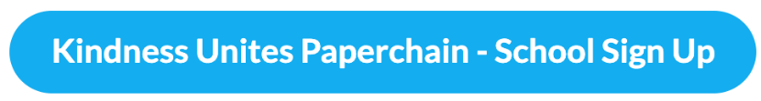](https://www.tfaforms.com/4872059)  
  
**How Many *Love Links* Per Student Should We Create?**  
Your students can be part of this unifying campaign by creating on average anywhere between 10 - 50 *Love Links* per student. Easy peasy!

The below table will help you calculate exactly how many links per student you will need to create in order to assemble a quarter mile, half a mile or one mile paperchain. Simply divide the amount of paper links by the number of students at your school. 

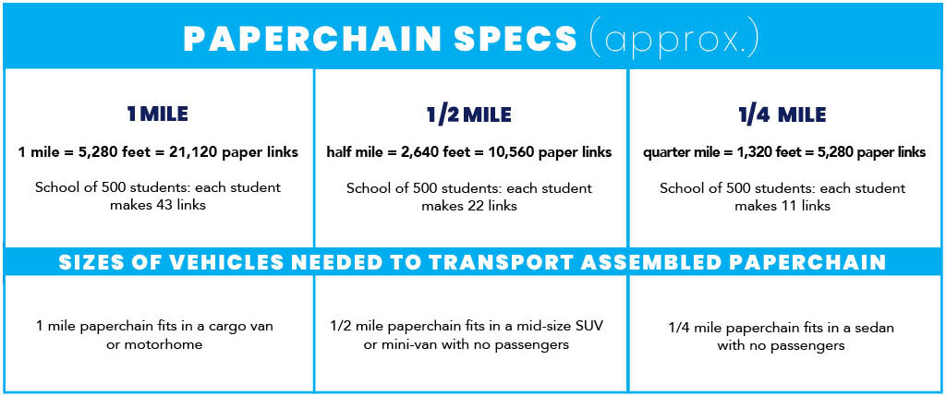

**How Can We Implement The Project?**

With the summer break approaching, this could be a fun and meaningful end of the school year activity. Some younger grade teachers use the project as an opportunity to practice writing skills (through the writing of uplifting words and messages). It can also be a math exercise through the measuring of the Love Links and the assembled paperchain. Not to mention, it’s a fun a fun art project using recycled materials! Students can create *Love Links* in the classroom, during recess or through a home assignment/project.

**How Do We Create *Love Links* And Assemble The Paperchain?**  
It's simple! Here are the step by step instructions:

**1**. **Gather Recycled/Reused Paper** – The weight of the paper should be thin enough to

easily bend and thick enough to create a sturdy link in the paperchain. Suggested materials: cereal/food boxes, craft paper scraps, brown paper shopping bags. Here is a quick video of [how to easily create Love Links from a paper bag](https://kidsforpeaceglobal.org/wp-content/uploads/2021/03/Love-Links-Out-Of-A-Paper-Bag.mov).

**2. Measure & Cut Links** – Each strip must be between 11 inches – 18 inches long and

1.5 inches wide.

**3. Decorate Love Links with Messages of Love & Hope** – Students may get as creative

as they’d like with markers, paint, crayons, sharpies, pencils or pens. The designs can be pretty simple ☺ and the more *Love Links* you can create the better!

**4. Assemble the Paperchain** – To ensure the paperchain is extra strong and secure, use

2 staples to attach each link. Allow for an approximate 1 inch overlap when connecting

each link.

**5. Measure the Paperchain** – Stretch out the paperchain and measure it from one end

to the other. You may use your school’s track and field to lay the paperchain for easy measuring. You can also use 2 dowels set up 30 feet apart, wrap the chain between the dowels 22 times to create 1/8 of a mile. If needs be, create more *Love Links* to ensure your paperchain meets the length you signed up for (either ¼, ½ or 1 mile long).

**6. Complete the Quick** [**School Certification Form**](https://thegreatkindnesschallenge.com/wp-content/uploads/2021/02/Kindness-Unites-Paperchain_School-Certification-Form.docx)

**7. Deliver Your Links & Certification Form** (please see below)

**Where Do We Deliver The Assembled Paperchain Or Flat *Love Links*?**  
For all participating schools in the San Diego vicinity, please hold on to your paperchain and we will keep you posted once we have the event date and location confirmed. You will be asked to deliver the assembled paperchain in person on the official Guinness World Record event day, which will be held in Carlsbad, CA.

If you are creating flat *Love Links*, you may mail them to, or drop them off at, the Kids for Peace HQ (1302 Pine Ave, Carlsbad, CA 92008). If delivering in person, please kindly text Jill at 760.846.0608 to arrange a drop-off time.

**All Participating Schools Will Be Acknowledged In The Following Ways:**

1. A special certificate to share with your school families
2. A social media post "My school has helped set a Guinness World Record" to share with your school network
3. School name listed:
   * in the GKC celebration video
   * on the GKC website
   * in a special celebration newsletter